**IS 441 Summer 2019 Class session 2 Summary: Degree and Cardinality; Associative Entity**

Dr. Ye “Jeff” Zhang, July 17 (for Class 0715), 2019

1. More complete and thorough (hopefully) explanation of cardinality

Take binary relationship as example: there are entity types A and B.

Table A (Entity A) Table B (Entioty B)

[Note: A and B can have different number of rows or columns – OF COURSE!!]

|  |  |  |  |  |  |  |  |  |  |
| --- | --- | --- | --- | --- | --- | --- | --- | --- | --- |
| Take | this | row | In A, | How many rows in B on the right are related?   * None? * One? * Many? |  |  |  |  |  |
|  |  |  |  |  |  |  |  |  |
|  |  |  |  |  |  |  |  |  |
|  |  |  |  |  |  |  |  |  |
|  |  |  |  |  |  |  |  |  |
|  | | | |  |  |  |  |  |
|  |  |  |  |  |

Take one row (one instance) from entity type A (one row from table A),

The two paragraphs are symmetrical! I actually copied and pasted the 1st paragraph, then changed “A” and “B”

How many rows in B can be associated with this one row in A?

This is the business rule “from left to right”:

“Each instance in A relates to ______ (number of) instances in B”

**Symmetrically:**

Take one row (one instance) from entity type B (one row from table B),

How many rows in A can be associated with this one row in B?

This is the business rule “from right to left”:

“Each instance in B relates to ______ (number of) instances in A”

Come back to the first paragraph: “For each row in table A”, there are the following possible scenarios:

|  |  |  |  |
| --- | --- | --- | --- |
| Scenario explanation | Formal term | Symbol | Stated also as: |
| 1. as few as none, as many as 1  (min 0, max 1) | Optional one |  | One or none;  at most one |
| 2. as few as none, as many as any #  (min 0, max M) | Optional many |  | Many or none;  Can be/have many but doesn’t have to |
| 3. as few as one, as many as 1  (min 1, max 1) | Mandatory one |  | One and only one |
| 4. as few as one, as many as any #  (min 1, max M) | Mandatory many |  | At least one;  Must have/be one or more. |

Note: In Scenario 4 (mandatory many), we can also indicate a minimum number that is more than one, or limit the maximum number to a fixed number, by writing a number at the cardinality symbol (please pay attention to the right end: **Min 20**, **max 40**) 20 40

1. Associative entity
2. When to use? When the entities involved have many-to-many relationship (such as STUDEANT and COURSE); usually also when this relationship has its own attributes, that cannot be in the table of either side (such as Grade).
3. What is the distinct feature of the symbol? The box representing associative entity has rounded-corners.
4. What is the distinct feature of the positioning of the associative entity symbol? It is in the middle of the original relationship line (in contrast to the “attributes of relationship” which would be on one side of the relationship line).
5. What can we say about the cardinality symbols AFTER the associative entity is introduced?
   1. The cardinalities at the associative entity are ALWAYS many (could be optional or mandatory, depending on the original cardinalities, but ALWAYS many);
   2. The cardinalities at the ends of the two original entities are ALWAYS mandatory one.
6. How would we determine the cardinalities in the above “4(a)”? Use “in the eyes of” logic.
7. What are the attributes of an associative entity?
   1. The composite key, a key that has two attributes, each taken from one entity that the associative entity connects
      1. (so there are two fields/attributes in an associative entity that was converted from a binary many-to-many, and
      2. there are three fields/attributes in an associative entity that was converted from a ternary relationship).
   2. Any other attributes that originally belonged to/assigned to the many-to-many relationship, such as
      1. Grade in STUDENT – COURSE relationship that is converted to ENROLLMENT associative entity;
      2. Certificate_Date in EMPLOYEE – TRANING_COURSE relationship that is converted to CERTIFICATE associative entity;
      3. Quantity in ORDER – PRODUCT relationship that is converted to ORDERLINE associative entity.
8. See the following picture of the three examples:

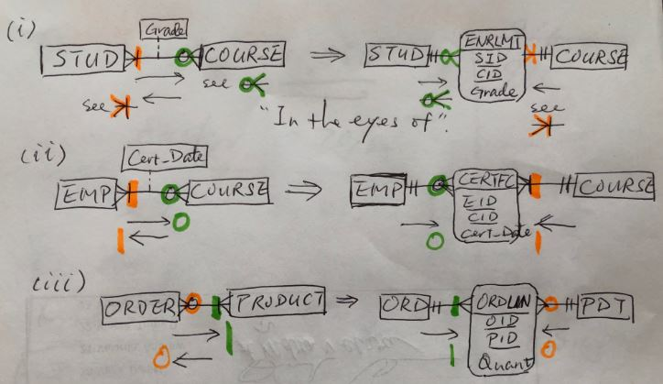

Watch the color-coded cardinality symbols to understand the logic of “in the eyes of”.